**How to request Time Off through SuccessFactors**

To Access your profile in Success factors, please follow the directions below:

Go to the Digital Workplace: <https://argoscorp.sharepoint.com/sites/dwp/en>, copy the URL and paste it in browser, you will be directed to the below screen.

Login with your email address or your employee ID.

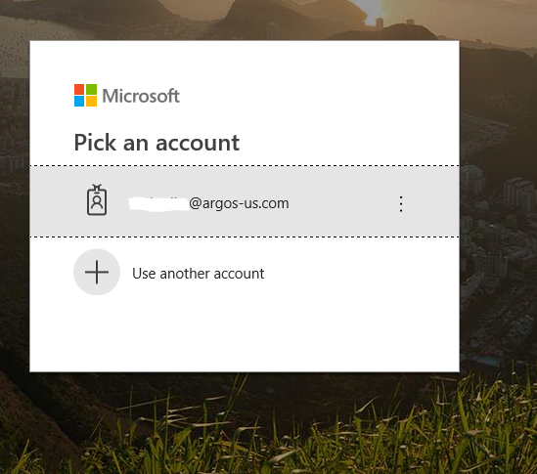

Once you enter in Digital Workplace, you will see the Success factors Icon as shown below.



Once you click on SAP Success factors Tile and you will come to the Success factors Home Page as shown below:

* Type your name on the search bar as shown below.

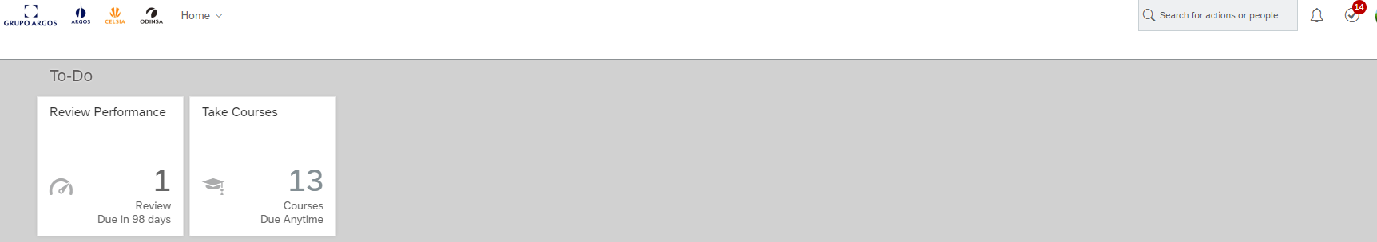

Once you type your name you will see your profile - My employee file, then Click on the **TIME OFF** tab

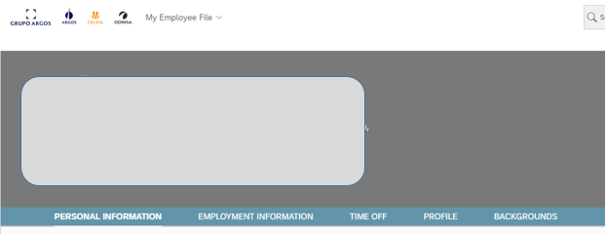

The system will show up with the below screen, then click on ***Go to Time Off***

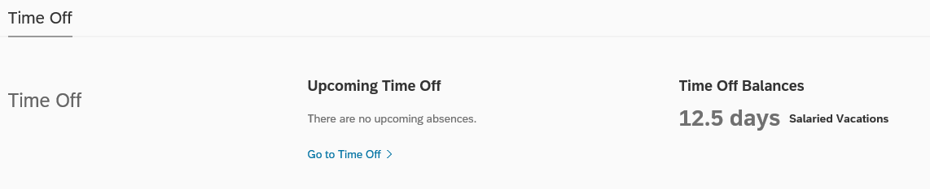

You will see the below screen with the Time Off Calendar:

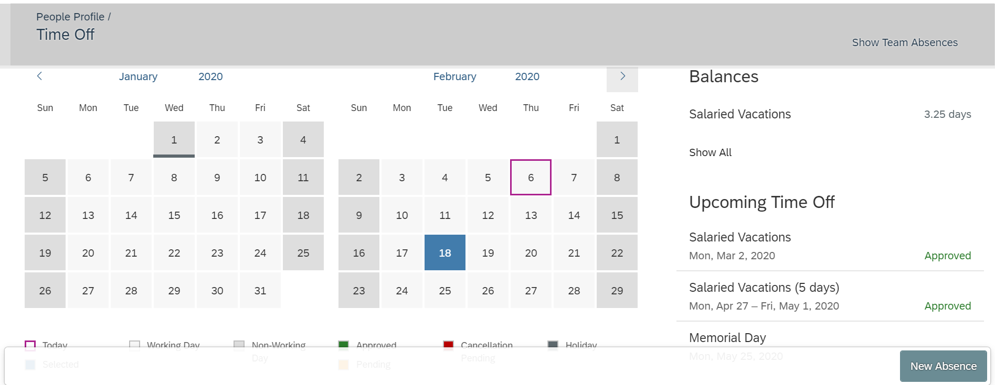

To the right you will see:

1. Vacation Accrual is listed under *Balances*
2. Upcoming Time Off that has already been requested and status of that request
3. **NEW ABSENCE** button to request a new Time Off

**To Request a NEW Time Off**:

1. Select the day(s) you are requesting and click on **NEW ABSENCE**

Then, you will see:

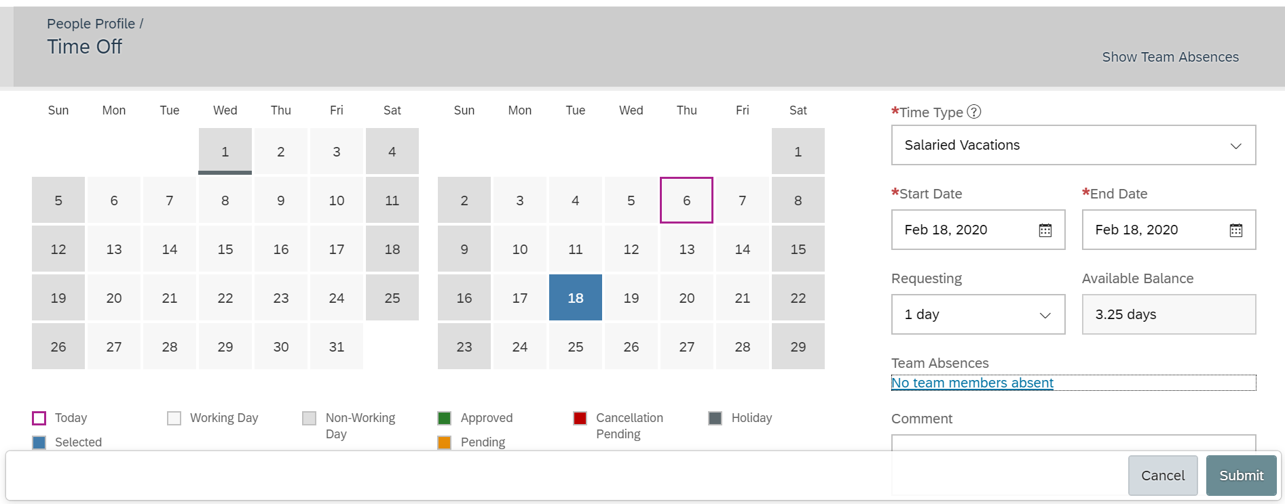

1. Confirm the start date and end date of Time Off request is accurate
2. Under *Requesting* - Choose if you are requesting 1 full day off or .5 (half) day off
3. Click **SUBMIT** – the Time Off request is now sent to your Manager for Approval

To **CANCEL** a future Time Off request that was already approved:



1. Click on the Upcoming Time Off you want to cancel
2. Click the **CANCEL** button – the cancellation request will now be sent to your Manager for approval

